1.INTRODUCTION:

* 1. Overview.

Naan Mudhalvan is a flagship initiative of the Tamil Nadu skill development corporation to

provide students with various skill training based on current industry demand for talent. The initiative assists student in learning in-demand skills that will prepare them for employment in the industry.

* 1. Purpose.

As part of Naan Mudhalvan intiative, you tube based experiential learning programme for the 5th semester students of Bsc. Maths groups from Government , Government added and private colleges across the states of Tamil Nadu as part of the Naan Mudhalvan in initiative.

2.PROBLEM DEFINITION & DESIGN THINKING

2.1 Empathy Map



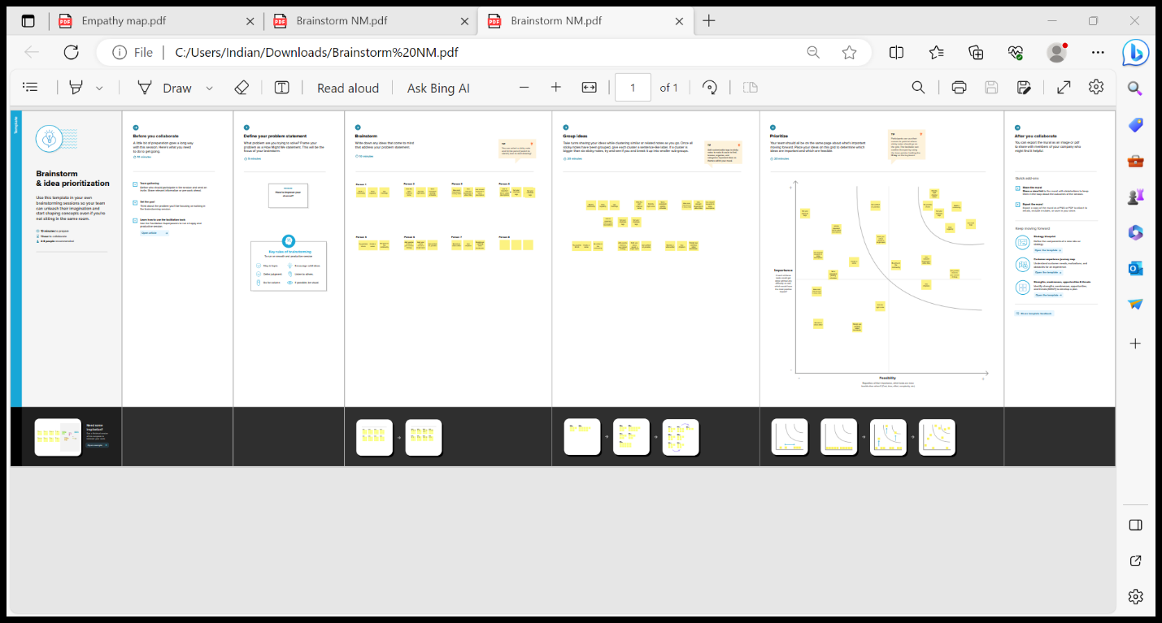3.RESULT

Final finding outputs of the projects along with the screenshots.

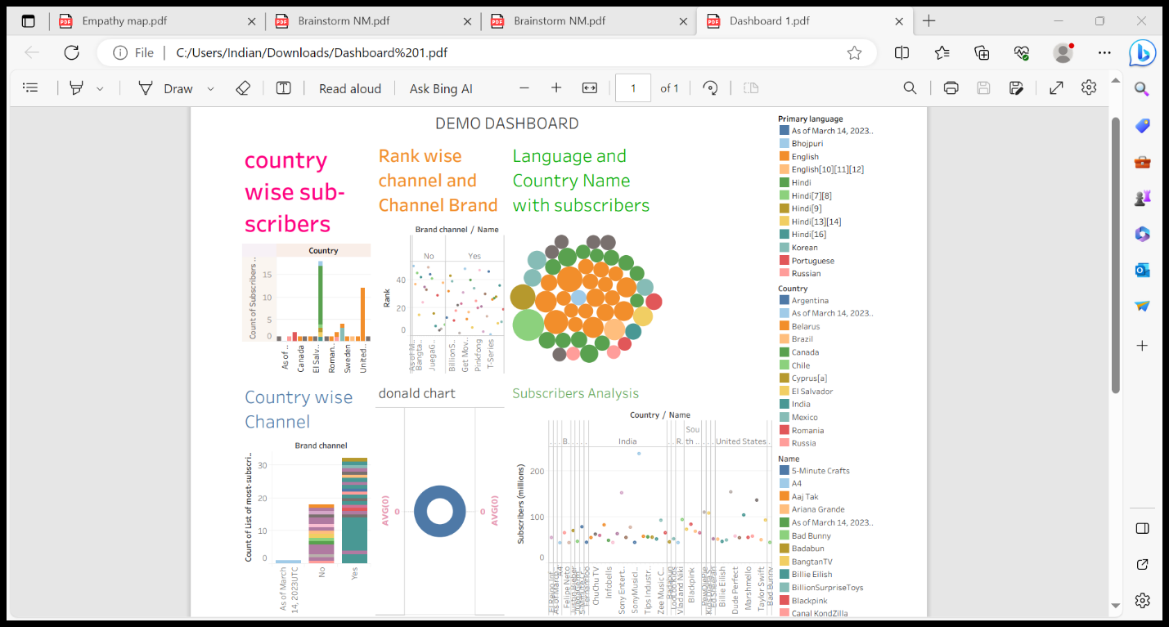

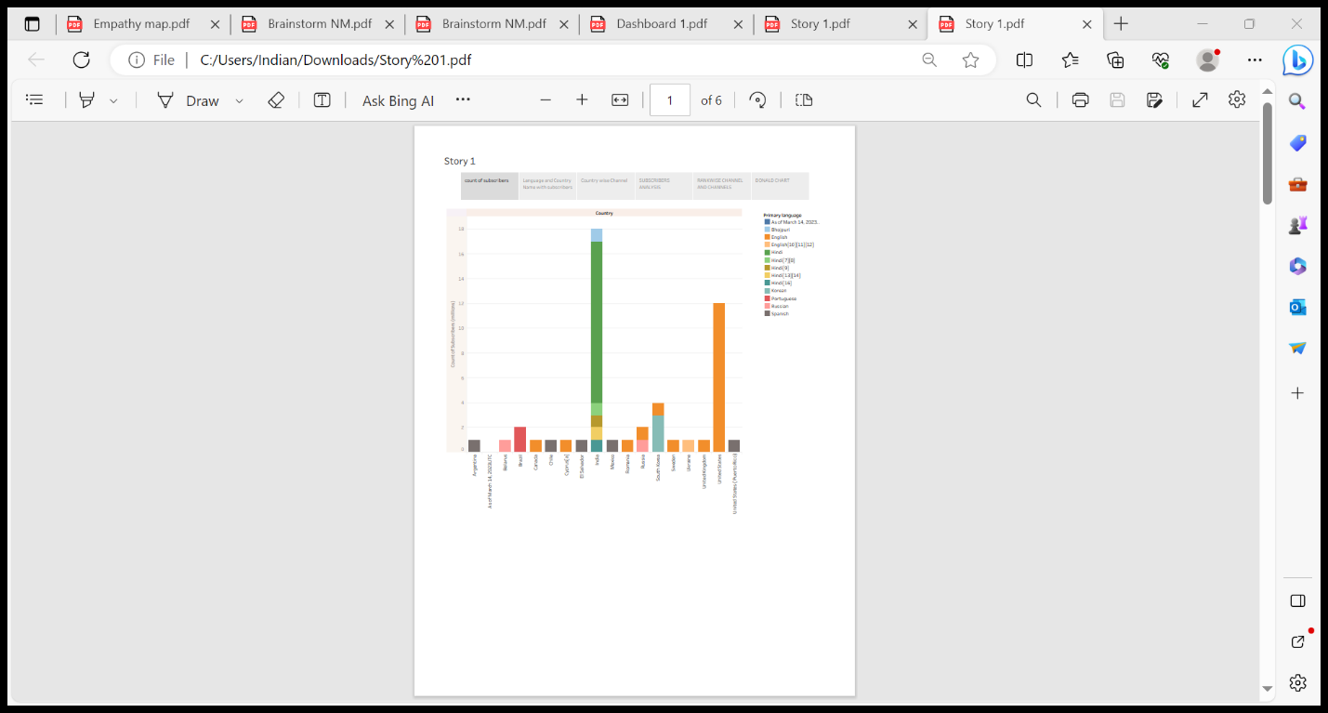





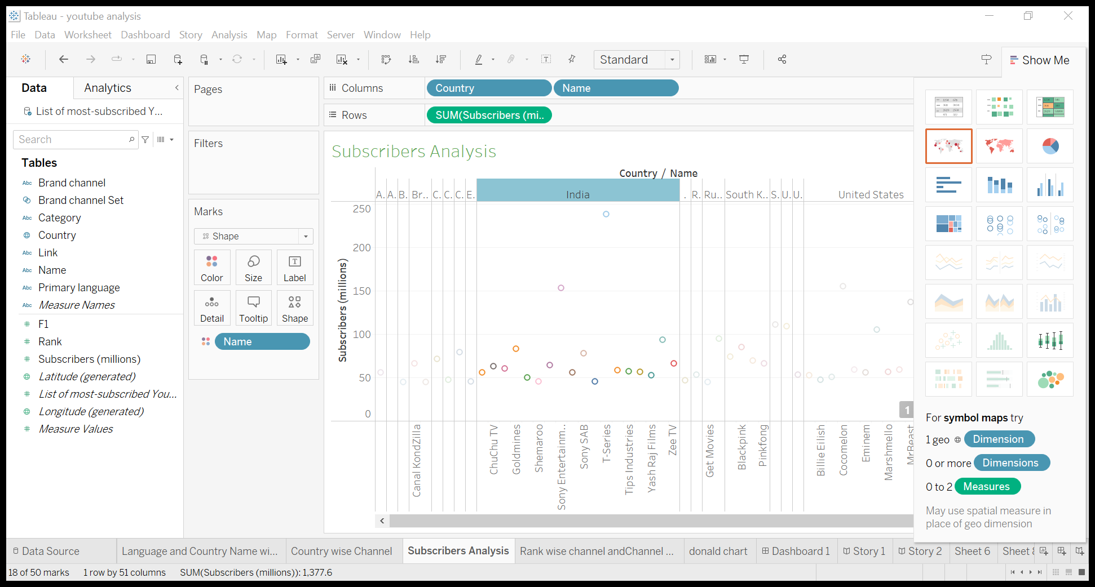

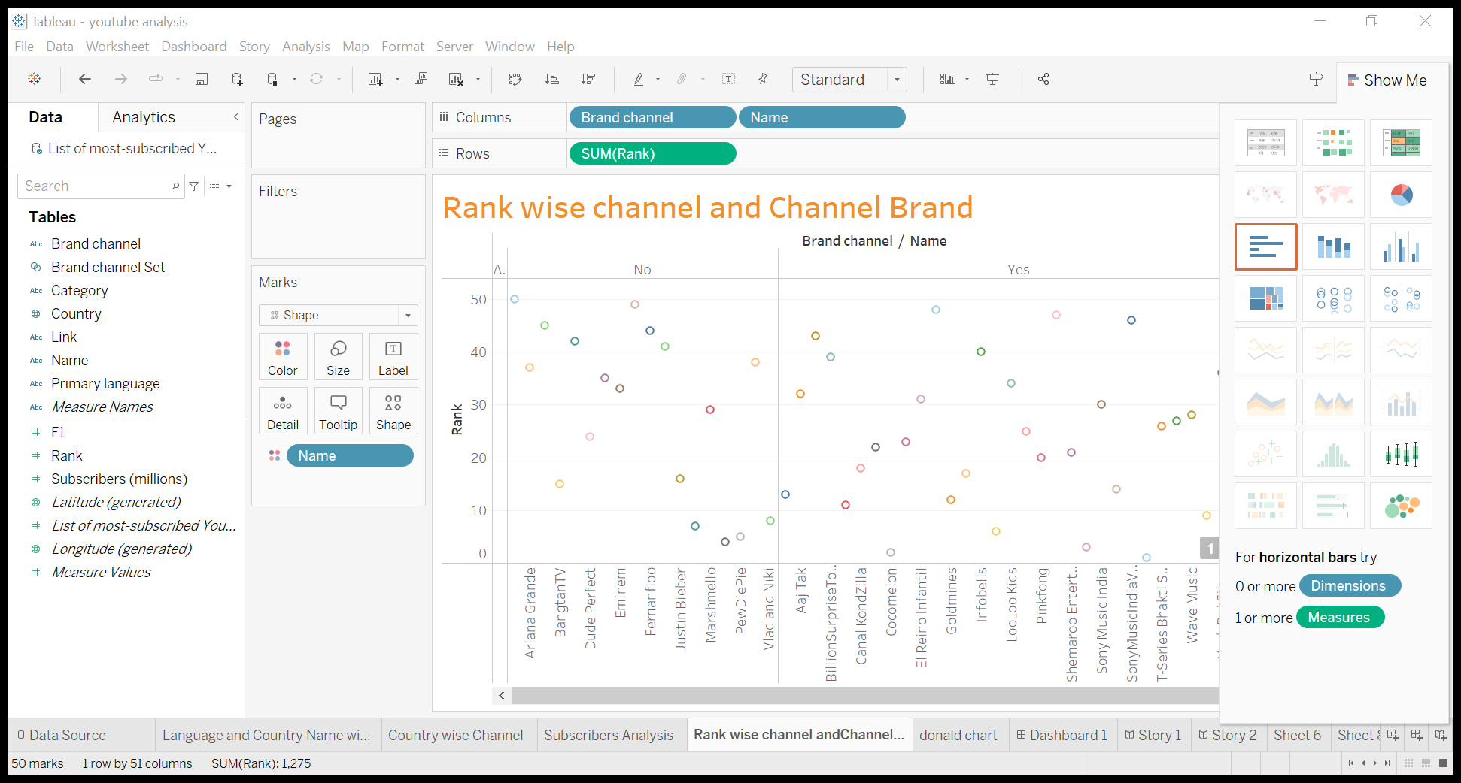





4.ADVANTAGES AND DISADVANTAGES.

Audience insights: Subscribers analysis provides valuable insights into the demographics and preferences of the audience of each channel. This can help content creaters and advertisers tailor their content and marketing strategies.

Privacy concerns : Collecting and analyzing subscriber data must be done with atmost care to product user privacy. Violating privacy regulations can lead to legal issues and reputational damage.

5.APPLICATIONS.

Within your analytics on you tube, you can click Advanced Mode in the top right corner to drill down into data , compare content performance, and export data. Sophisticated marketers and marketing teams will find this mode a veritable treasure trove of information.

There are tones of features in Advanced Mode that you don’t want to sleep on. Google support created a very useful map of the available features ; check it out to ensure you are not missing anything.

6.CONCLUSION.

You tube is a very strong growing platform creating lots of opportunities for entrepreneur and motivated people. The best way to succeed at it , apart from creating good video content , is knowing what people like and knowing how to reach those people, for which of course you will need a mastery of social media.

7.FUTURE SCOPE.

You tube will continue to be where people go for informative and educational videos. You tube with a decent number of subscriber on their you tube channel can earn money per month. People online are searching for relevant, entertaining , educating and inspiring information.